4. Plot of Great Circles in Various Projections
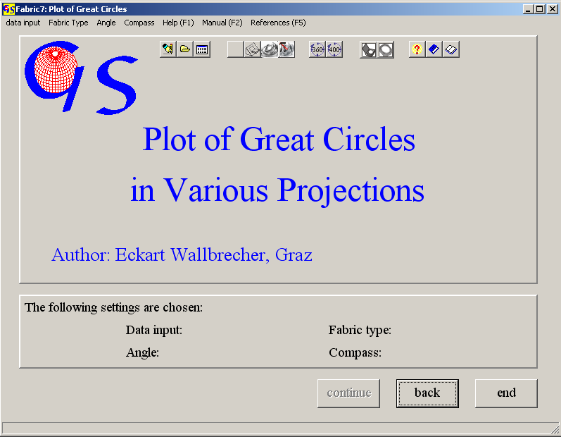
Fig.. 1

With this program (Fig. 1) planes are plotted as great circles. The used projections are the same as in program 3. The used algorithm is described by WALLBRECHER (1986:39ff). Data input is the same as in program 3. Since data are planes, the extension of data files is *.PLA.
Fig. 2 shows the graphic form. Menus and settings are the same as in program 3.
The menus "Hemispere" and "Projection are the same as in program 3.
In the menu “Plot poles” you have the option to plot the poles to the great circles (Fig. 3). In the menu “Symbol” you can choose the symbols for the poles to the planes (Fig. 4) and you can set the line style and thickness (Fig.5) of the great circles.
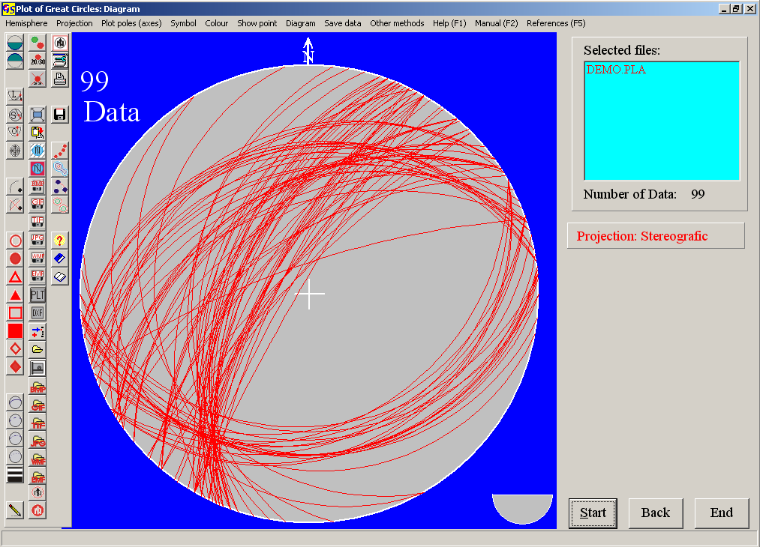
Fig. 2

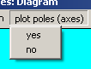
Fig. 3
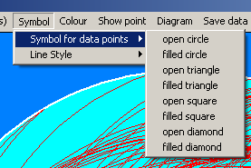
Fig. 4

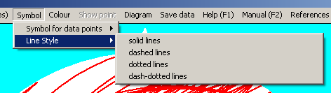
Fig. 5

The menus "Colour", "Show point", "Diagram", "Save Data", and "Other methods" are the same as in program 3.

